

# Computer & Electronic Engineering

# Final Year Project "Music Host Interface"

# Sprint 8: Week 2 Log

# Thomas Flynn

# Project Supervisor: Brian O'Shea

# 11/04/16 - 17/03/16

# 1 Log Entries

## 1.1.0 Entry 1: 15/04/16

Today I fixed a bug in my add song animation.

## 1.2.0 Entry 2: 16/04/16

Today I fixed the skip song bug for my android application. The solution was to have FX server thread sleep briefly while the song was being skipped before responding to the android client.

## 1.3.0 Entry 3: 17/04/16

Today I started UML diagrams for my report.

# 2 GIT Repositories:

No commits made this week.

# 3 Toggl Time Logs

## 3.1 Weekly time Log bar chart:

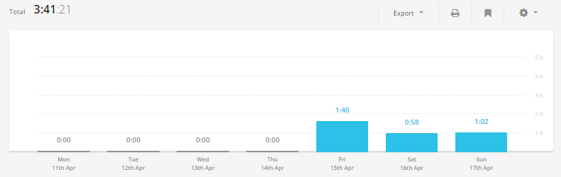

## 3.2 Weekly Time Log:

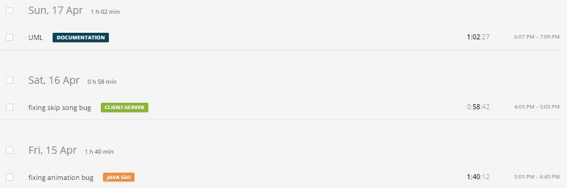

## 3.3Weekly log Pie Charts:

